MARKING KEY

0000.doc

PHYSICS
SECTION ONE: SHORT ANSWER

Question 1(a)
Wave period
Description | Mark
Period = 12 s. | 1

Question 1(b)
Wave frequency
Description | Mark
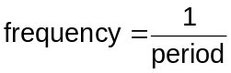 | 1
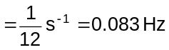. | 1

Question 1(c)
Number of waves
Description | Mark
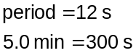 | 1
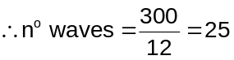. | 1

Question 2
Light bulb
Description | Mark
 | 1
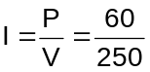 | 1
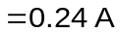. | 1

Question 3
Standing waves
Description | Mark
The lines represent the maximum amplitude, at any point, of the air molecules in the tube. | 1

Question 4(a)
Alternating current
Description | Mark
The emf alternates OR the current direction alternates. | 1

Question 4(b)
AC home delivery
Description | Mark
High voltages are more efficient for long distance power transmission. | 1
Low voltages are safer for domestic use. | 1
AC allows transformers to step current up and down. | 1

Question 5
Seesaw
Description | Mark
Assume: child has mass 25 kg (allow 5-50 kg) | 1
Assume: child is 2 m from the fulcrum (allow 1-4 m) | 1
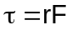 | 1
. (allow 49-1960 m N) | 1

Question 6
Magnetic field
Description | Mark
False. | 1
Moving charges create magnetic fields. | 1

Question 7(a)
Electric field
Description | Mark
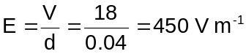 | 1

Question 7(b)
Electric field
Description | Mark
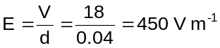 | 1

Question 8(a)
Transformer
Description | Mark
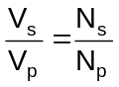 | 1
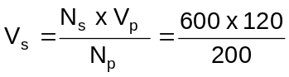 | 1
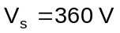 | 1

Question 8(b)
Current in transformer
Description | Mark
In an ideal transformer, P_{in} = P_{out} | 1
so  | 1
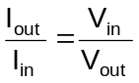, so 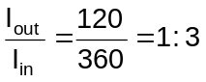 | 1

Question 9
Big bang
Description | Mark
The Universe is expanding. | 1
The rate of recession for galaxies etc increases with distance. | 1

Question 10
Force between moons
Description | Mark
Minimum force is when they are furthest apart.  Distance = (4.22 x 10⁸ + 1.07 x 10⁹)m = 1.492 x 10⁹ m apart | 1
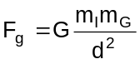 | 1
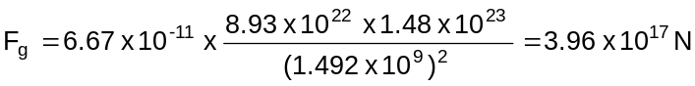 | 1

Question 11
Quasars
Description | Mark
Red shift is a Doppler effect showing that the emitter is moving away from us. | 1
Large red shift means high recession rate. | 1
Recession rates increase with distance. | 1

Question 12
Lenz’s law
Description | Mark
Aluminium is a good conductor. | 1
The falling magnet’s magnetic field induces eddy currents in the tube. | 1
These eddy currents oppose the change that created them (Lenz’s law) and slow down the falling magnet. | 1
Plastic is not a conductor so no eddy currents are created in it. | 1

Question 13
Circular motion free body diagram
Description | Mark
 | 1
Angle between pole and chains:  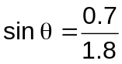  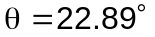 | 1
Tension in each chain has vertical component = half the child’s weight  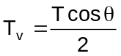 | 1
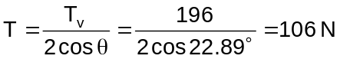. | 1
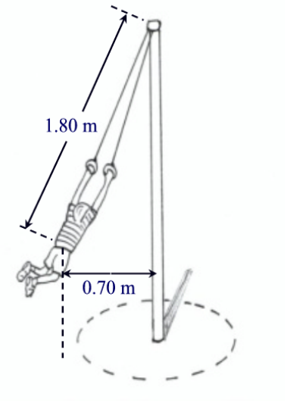  106 N  196 N  106 N | 2

SECTION TWO: PROBLEM-SOLVING

Question 14(a)
Standing wave formation
Description | Mark
The quiet places are displacement nodes (or pressure antinodes) in a standing wave. | 1
The two speakers had the same frequency, and in air both have the same wavelength and speed. | 1
A standing wave forms from interference between two such waves, travelling in opposite directions. | 1

Question 14(b)(i)
Error reduction
Description | Mark
B: Measure the distance between several quiet spots | 1

Question 14(b)(ii)
Explaining error reduction
Description | Mark
Measuring a greater distance involves the same absolute error. | 1
Sam should divide the distance by the number of internodal distances to determine the value for one internodal distance. | 1
This reduces the relative error in distance measurement. | 1

Question 14(c)
Speed of sound
Description | Mark
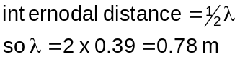 | 1
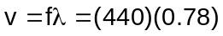 | 1
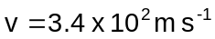. | 1

Question 15(a)(i)
Frequency of AC
Description | Mark
83.3 Hz. | 1

Question 15(a)(ii)
Power to lamp
Description | Mark
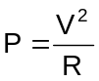 | 1
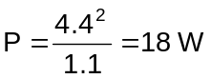. | 1

Question 15(b)
Magnetic field strength
Description | Mark
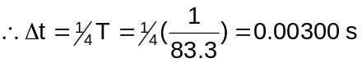 | 1
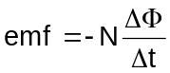 | 1
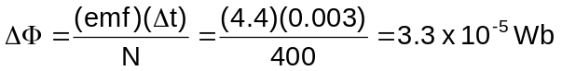 | 1
In ¼ turn, 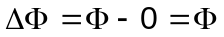 | 1
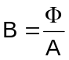 | 1
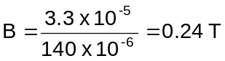. | 1

Question 15(c)
Commutator used to change to DC
Description | Mark
Required commutator is a split ring. | 1
This reverses the induced current in phase with the reversal of the field through the coil. | 1
In effect this keeps current direction constant. | 1

Question 16(a)(i)
Trajectory
no air resistance
with air resistance

Description | Mark
Parabolic shape. | 1
Starts above ground, ends on the ground. | 1

Question 16(a)(ii)
Effect of air resistance
Description | Mark
Starts along the same path, becomes more strongly curved. | 1

Question 16(a)(iii)
Explaining effect of air resistance
Description | Mark
Air resistance decreases the forward component of velocity. | 1
So the ball does not travel as far forward in the time of flight. | 1

Question 16(a)(iv)
Acceleration of ball
Description | Mark
No. | 1
The ball is continually subject to the acceleration due to gravity. | 1

Question 16(b)(i)
Flight time
Description | Mark
Vertical component of initial velocity 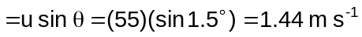 | 1
Vertical motion 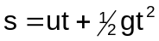; let up be positive. | 1
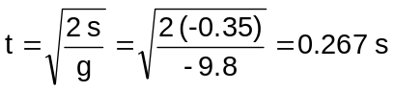. | 1

Question 16(b)(ii)
Range
Description | Mark
Horizontal component of initial velocity | 1
Horizontal motion 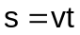. | 1
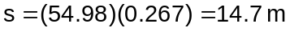 | 1

Question 17(a)(i)
Plotting v² vs T
Description | Mark
v² vs T gives a straight line, v vs T does not OR v vs T does not map the function. | 1
A straight line allows gradient to be calculated more easily and accurately. | 1

Question 17(a)(ii)
Units of 
Description | Mark
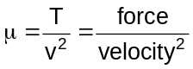 | 1
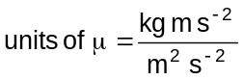 . So the units of μ are kg m⁻¹ (accept N s² m⁻²). | 1

Question 17(b)
Experimental value for μ
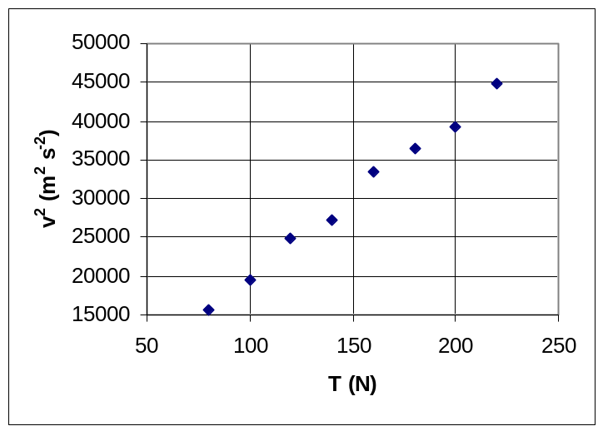

Description | Mark
Draw line of best fit by eye. | 1
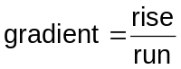 | 1
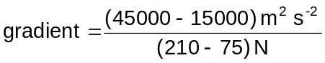  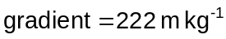 | 1
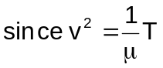, thus 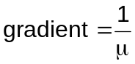 | 1
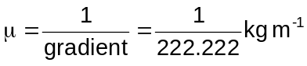  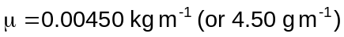. | 1

Question 17(c)
Fundamental mode when stretched

Description | Mark
The wave velocity is 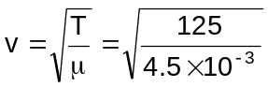 =166.7 m s⁻¹ | 1
The wavelength is (2 × 0.76) m | 1
so we can find the frequency  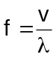 = 110 Hz. | 1

Question 18(a)
Motion of positive ions
B into page
+
_
X
X
X
X
X
X
X
X
X
X
X
X
Description | Mark
Path is curved | 1
To the left. | 1

Question 18(b)
Motion of negative ions

B into page
+
_
X
X
X
X
X
X
X
X
X
X
X
X

Description | Mark
Path is curved. | 1
To the left. | 1

Question 18(c)
How the pump works
Description | Mark
The electric field accelerates both positively and negatively charged particles so they move across the tube. | 1
Charged particles moving across magnetic field lines experience a magnetic force at right angles to both the movement and the magnetic field. | 1
This pushes the charged particles to the left whether their charge is positive or negative. | 1
The charged particles drag the solution with them as they move, so the pump moves the entire solution. | 1
As particles leave the pump to the left, more arrive from the right and the process repeats. | 1

Question 18(d)
Energy transfer in pump
Description | Mark
The electric field transfers energy to the charged particles. | 1
The charged particles transfer energy to the liquid. | 1
The magnetic field does not transfer energy to the charges. | 1

Question 19(a)(i)
Ionisation energy
Description | Mark
Minimum energy = 5.3 eV | 1

Question 19(a)(ii)
Process
Description | Mark
The arrow represents an electron falling to a lower energy level. | 1
The result is the emission of a photon. | 1
Whose energy is equal to the energy difference between the levels. | 1

Question 19(b)(i)
Two yellow lines
Description | Mark
Two energy levels are very close together. Electron transitions from these energy levels to the ground state produce almost equal wavelengths. | 1
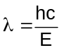 | 1
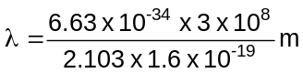  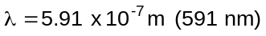 (allow 590-592 nm) | 1

Question 19(b)(ii)
Electron transition
Description | Mark
____________________ 0eV  ____________________ -1.009  ____________________ - 1.372  ____________________ -1.935  -3.026  -3.028  ____________________ -5.130  X  On diagram: Any transition with a lower energy level difference, e.g. the transition labelled X above. | 1
Explanation: Lower energies correspond to longer wavelengths. | 1

Question 19(c)
Using the spectrum
Description | Mark
Each line in the spectrum represents a transition between energy levels. | 1
These transitions are unique to each element and so can be used to identify specific elements. | 1

SECTION THREE: COMPREHENSION

Question 20(a)(i)
Producing X-rays
Description | Mark
X-rays are produced when high energy electrons are rapidly decelerated—as when striking the molybdenum target. | 1
The peaks result when electrons are lost (‘knocked out’) from the lowest energy levels (shells) of a molybdenum atom. | 1
When electrons from higher levels drop into the vacant spaces, X-rays of a specific energy are produced.  Note: K_{α} results from electron transition from L shell to K shell  K_{β} results from electron transition from M shell to K shell | 1

Question 20(a)(ii)
Electron energy
Description | Mark
35 kV | 1
Max energy of incoming electrons corresponds to shortest wavelength  X-ray = 0.035nm (estimate) | 1
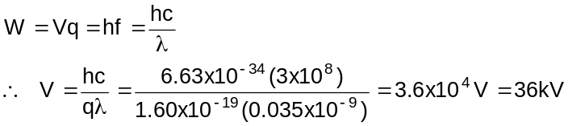  [possible range that might be calculated = 35-41 kV] | 1

Question 20(b)(i)
Table
Element | Wavelength (m) | 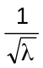 (m^{-½})
Molybdenum | 5.4 x 10⁻¹¹ | 1.4 x 10⁵
Tin | 3.8 x 10⁻¹¹ | 1.6 x 10⁵
Barium | 3.0 x 10⁻¹¹ | 1.8 x 10⁵
Ytterbium | 1.9 x 10⁻¹¹ | 2.3 x 10⁵
Tungsten | 1.7 x 10⁻¹¹ | 2.4 x 10⁵
Platinum | 1.5 x 10⁻¹¹ | 2.6 x 10⁵
Lead | 1.4 x 10⁻¹¹ | 2.7 x 10⁵

Description | Mark
Wavelengths all correctly calculated OR mostly correct (1 mark) | 2
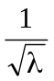 all correctly calculated OR mostly correct (1 mark) | 2

Question 20(b)(ii)
Graph
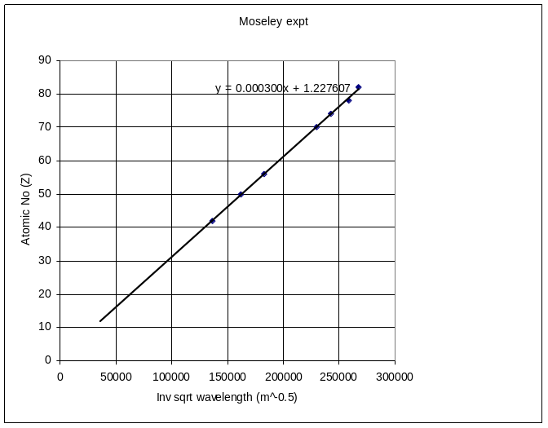

Description | Mark
Axes marked. | 1
Points plotted. | 1
Line of best fit. | 1

Question 20(c)(i)
Gradient
Description | Mark
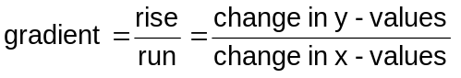 | 1
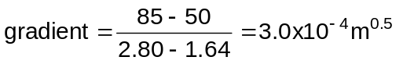 | 1

Question 20(c)(ii)
Gradient
Description | Mark
two significant figures | 1
since both Z and λ are given to 2 SF (and gradient is the ratio of these two) | 1

Question 20(d)
Gradient
Description |  |  | Mark
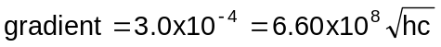 |  |  | 1
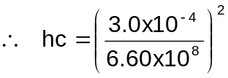 |  |  | 1
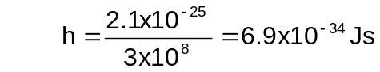  reasonable range = 6.4 – 7.3 (x10⁻³⁴)  If using 2.5x10⁻⁴, h = 4.8x10⁻³⁴Js |  |  | 1

Question 21(a)
Magnetic field direction
Description | Mark
Into the page. | 1

Question 21(b)
Identify ion
Description | Mark
Ion 1. | 1
It has a greater mass. | 1
From the equation, it must also have a greater path radius. | 1

Question 21(c)
Ionising atoms with an electrons beam
Description | Mark
Electrons in the beam have large kinetic energies and can remove an electron from the target atoms i.e. ionise the atom positively. | 1

Question 21(d)(i)
Accelerating electric field

Ions created here
Accelerating electric field
Ions exit here

Description | Mark
Straight lines, orientation to left. | 1

Question 21(d)(ii)
Kinetic energy of ion
Description | Mark
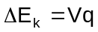 | 1
OR 25 keV (2 marks) | 1

Question 21(d)(iii)
Radius of ion path
Description | Mark
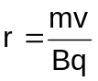 | 1
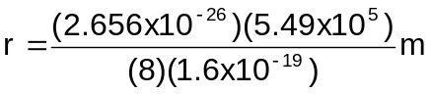 | 1
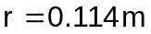. | 1

Question 21(e)
Isotope ratios
Description | Mark
The ice core will have a ratio of 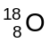 to 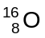 that reflects the conditions at the time because the ice forms from rainfall. | 1
The cave sample will have a different 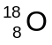 to 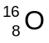 ratio because of the effect of calcium carbonate deposition…. | 1
….added to the effect of rainfall. | 1
The final ratio of the cave sample will depend on which effect is greater. | 1

Physics Stage 3 exam

 | 3A |  |  |  | 3B
 | Working in physics | Motion and forces in a gravitational field | Electricity and magnetism |  | Working in physics | Particles, waves and quanta | Motion and forces in electric and magnetic fields
SECT A
1 |  |  |  |  |  | X
2 |  |  | X
3 |  |  |  |  |  | X
4 |  |  | X
5 |  |  | X
6 |  |  |  |  |  |  | X
7 |  |  |  |  |  |  | X
8 |  |  | X
9 |  |  |  |  |  | X
10 |  | X
11 |  |  |  |  |  | X
12 |  |  | X
13 |  | X
SECT B
14 |  |  |  |  | X | X
15 |  |  | X
16 |  | X
17 |  |  |  |  | X | X
18 |  |  |  |  |  |  | X
19 |  |  |  |  |  | X
SECT C
20 |  |  |  |  | X | X
21 |  |  |  |  |  |  | X

